Rubric for Textbook Response

- Writing Standard 9-12.4, Development, Organization, and Style
- Reading Literature/Informational Text, Standard 9-12.1: Cite Strong and Thorough Textual Evidence

An “A” response will do all or most of the following:
- Writes in complete sentences
- Restates the question as part of the answer
- Directly cites (quotes) the part of the story or essay that supports the answer by giving an example, uses transitions, and indicates who is being quoted (attribution)
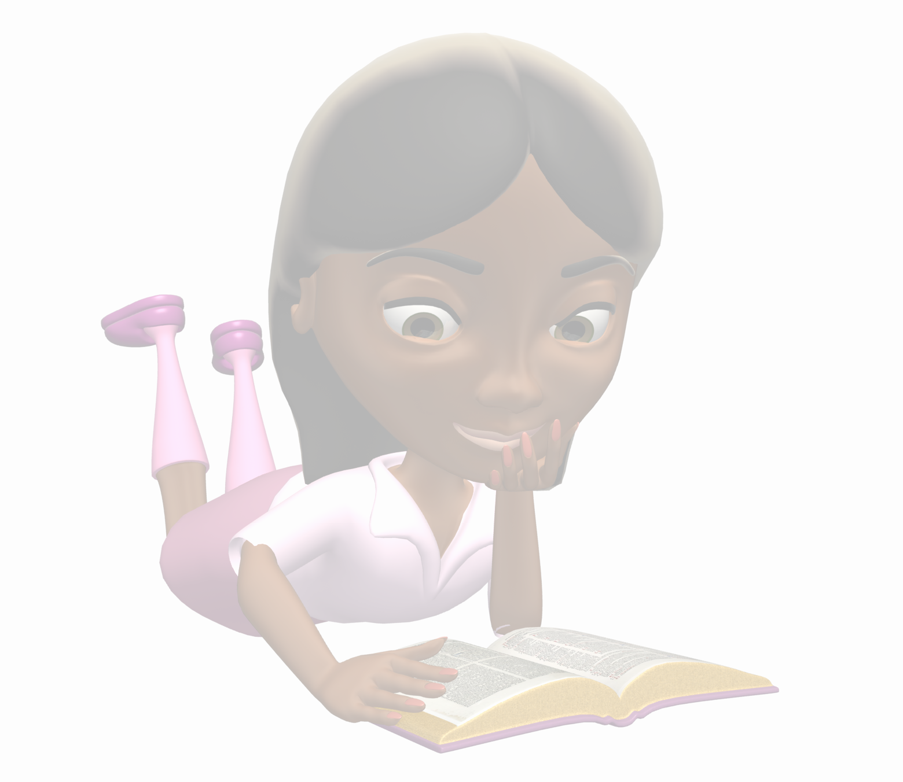
- Correctly uses parenthetical citation where needed
- Thoroughly explains how the cited examples supports the answer
- Answers all parts of the question correctly
- Answer is at least three sentences long
- Relatively few spelling, grammatical, or mechanical errors

A “B” response will do all or most of the following:
- Writes in complete sentences
- Restates the question as part of the answer
- Paraphrases or summarizes the part of the story or essay that supports the answer
- Explains how the paraphrased or summarized examples supports the answer
- Answers all parts of the question correctly
- Answer is at least three sentences long
- Minor spelling, grammatical, or mechanical errors

A “C” response will do all or most of the following:
- Writes in complete sentences
- Restates the question as part of the answer
- Briefly paraphrases or summarizes the part of the story or essay that supports the answer
- Briefly explains how the paraphrased or summarized examples supports the answer
- Most parts of the question answered correctly
- Spelling, grammatical, or mechanical errors occur

An “L” response will do all or most of the following:
- Writes in incomplete sentences
- Question not restated as part of the answer
- Question partially answered but not explained
- Most or all parts of the question are answered incorrectly
- Distracting spelling, grammatical, or mechanical errors

